Introduction to Database

Date: 6 feb 2019

**Exercise**

**Problem Statement:** There can be multiple customers, who can place multiple orders on the site. Now a sales person can handle these orders will distribute into multiple sales persons (One order will be assign to one salesperson only). So a sales person can have multiple orders of multiple customers

1. **Create Database**

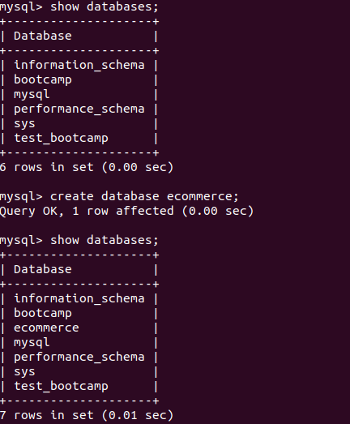

1. **Design Schema**

**ER Diagram for above problem statement:**

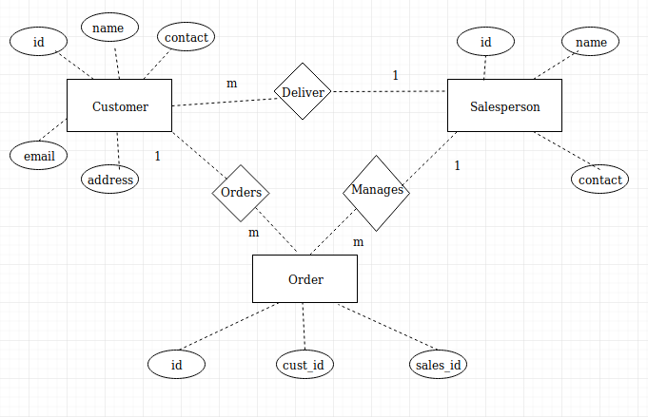

i) Schema for Customer table.

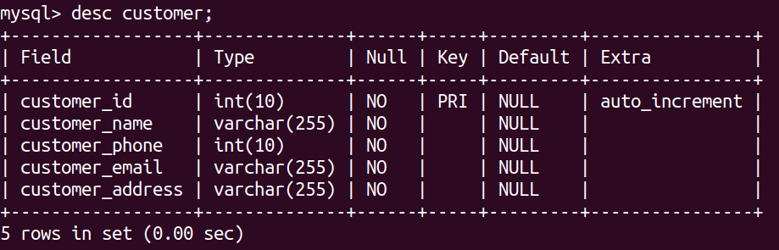

ii) Schema for Orders table.

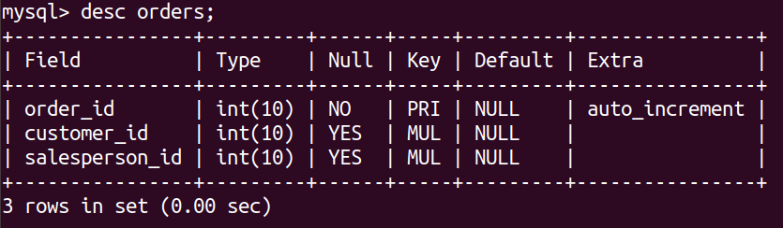

iii) Schema for Salesperson table.

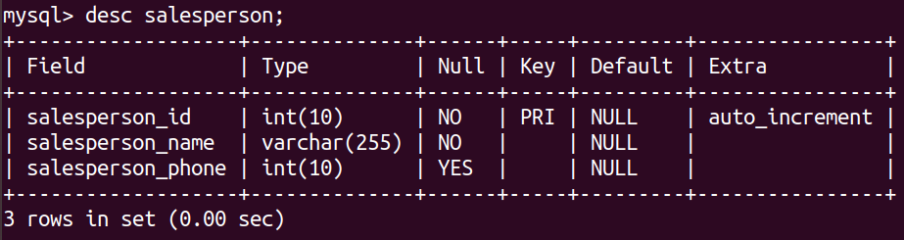

1. **Create tables**

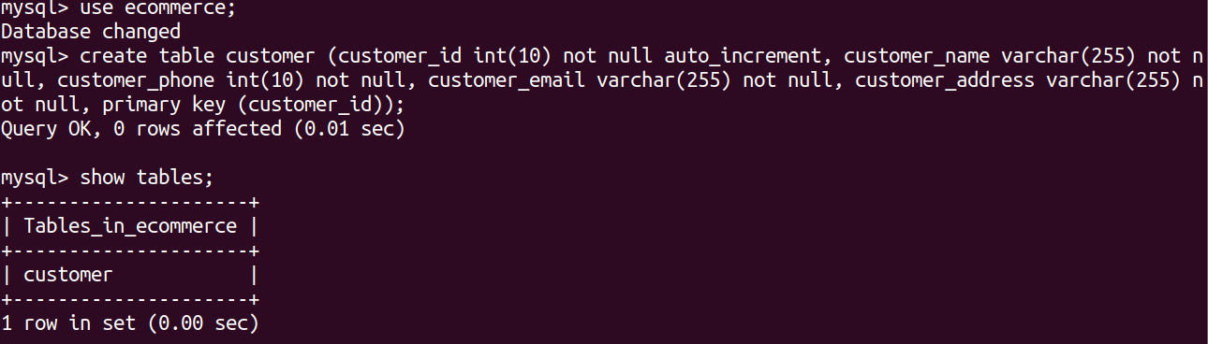

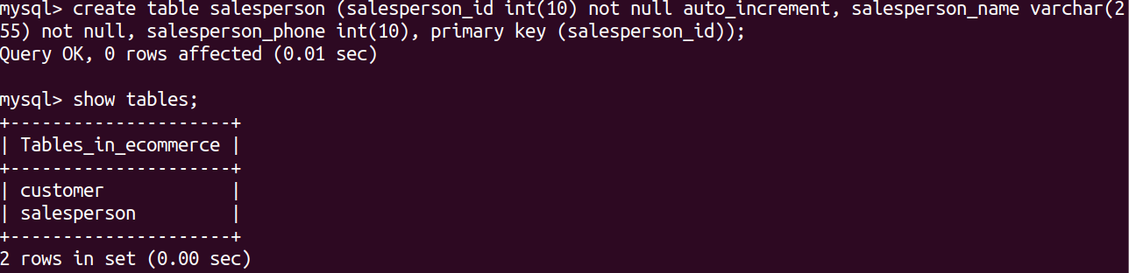

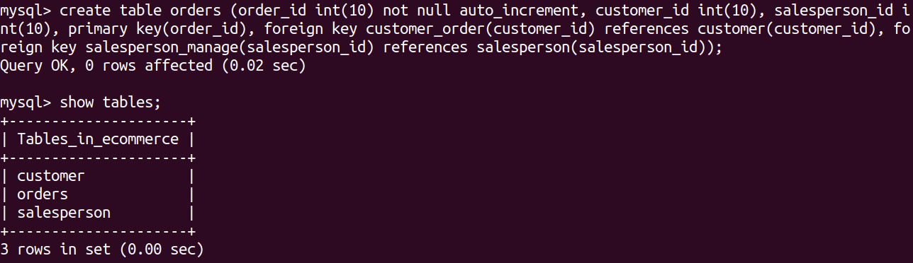

1. **Insert sample data**

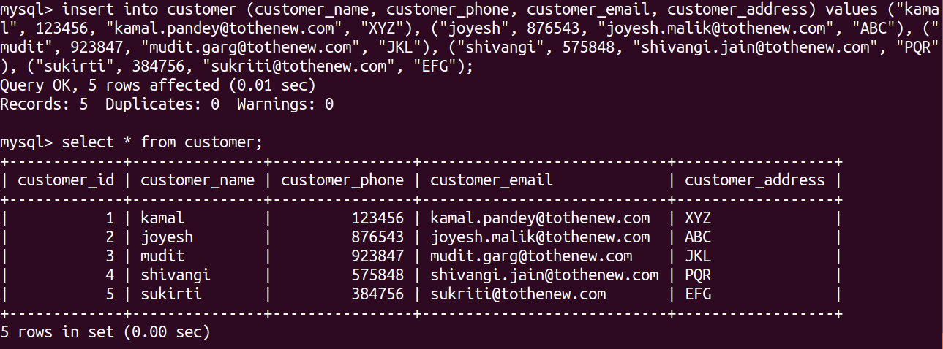

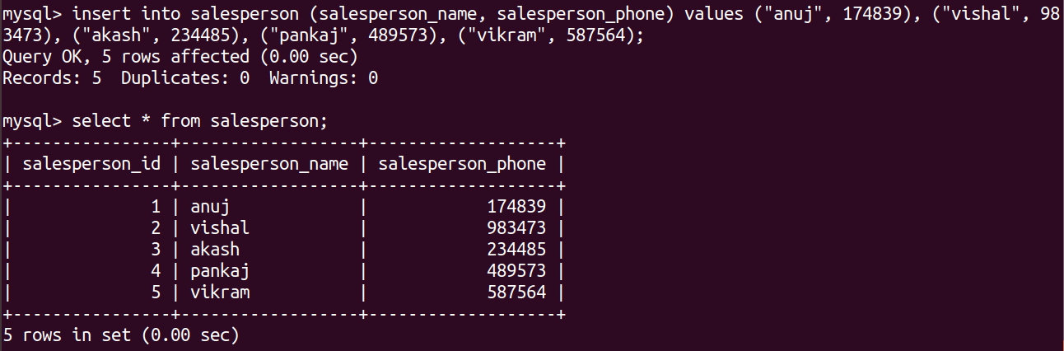

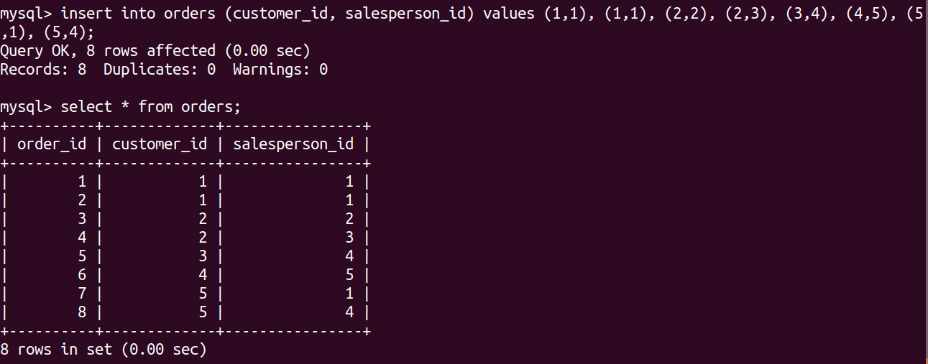

1. **Find the sales person have multiple orders.**

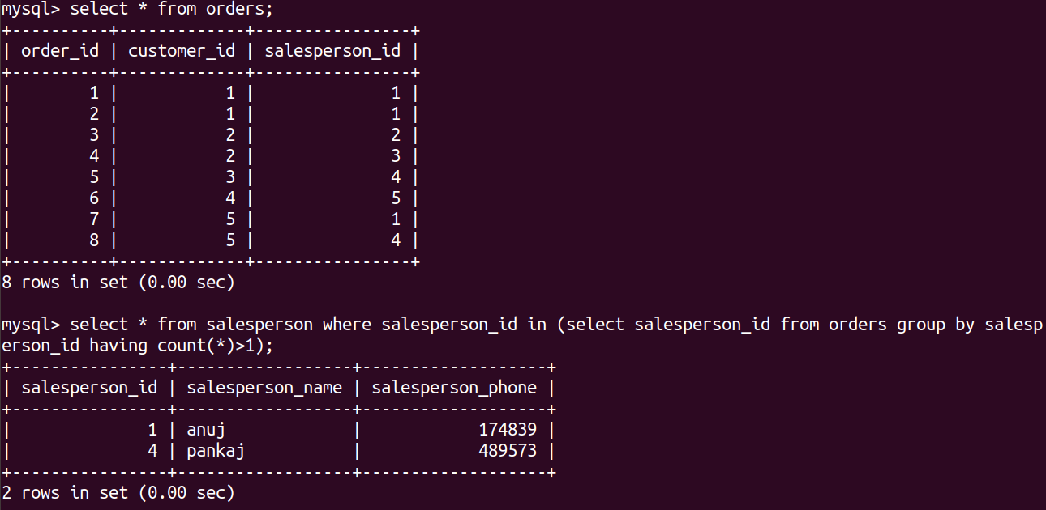

1. **Find the all sales person details along with order details**

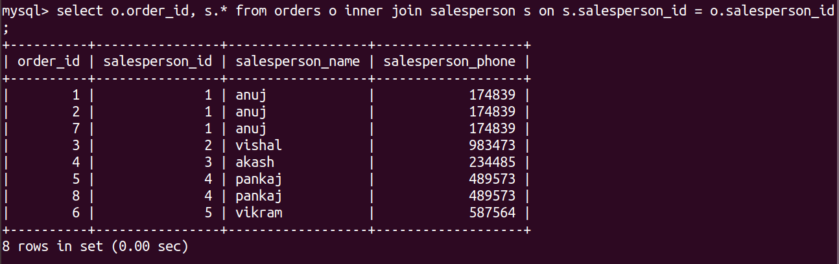

1. **Create index**

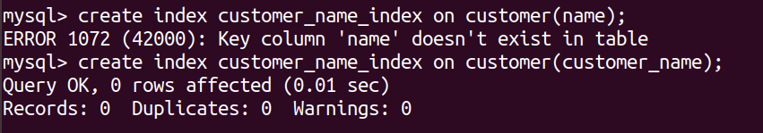

1. **How to show index on a table**

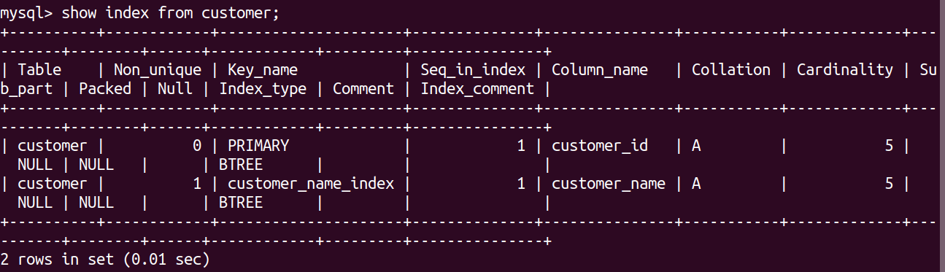

1. **Find the order number, sale person name, along with the customer to whom that order belongs to**

